**ADDRESS BOOK APPLICATION FLOW**

**1.Aim of the Project**

The aim of an Address Book application in Python using Object-Oriented Programming (OOP) is to create a structured, maintainable, and scalable application that can store, retrieve, modify, and manage contact information. The application should provide a user-friendly interface and implement features such as adding, deleting, searching, and updating contacts, all while adhering to OOP principles like encapsulation, inheritance, and polymorphism.

An address book is a collection of contact information for individuals and organizations. This information can include names, addresses, phone numbers, email addresses, and other details. A program that allows you to manage your address book is a great tool for keeping track of your contacts.

**2.Business Problem or Problem Statement**

Design and implement an Address Book Application using Python and Object-Oriented Programming (OOP) principles to efficiently manage a collection of contacts. The application should allow users to perform various operations on the contacts, including adding, viewing, editing, deleting, and searching. The system should be intuitive, scalable, and adhere to OOP best practices.

• **Contact Management:**

* Storing and managing multiple contacts with attributes such as name, phone number, email, and address.
* Handling duplicate entries effectively.

• **Search and Retrieval:**

* Allowing users to search for specific contacts based on various criteria (e.g., name or phone number).
* Displaying search results in a user-friendly format.

• **Data Integrity:**

* Validating input to ensure contacts have valid names, phone numbers, emails, and addresses.
* Preventing data corruption or loss during updates or deletions.

• **Persistence and Scalability:**

* Ensuring contacts persist beyond a single runtime by implementing file-based or database storage.
* Designing the system to accommodate future enhancements (e.g., importing/exporting contacts, categorization).

• **User Experience:**

* Providing a clear and intuitive user interface for command-line interaction.
* Offering informative feedback for all operations (e.g., successful additions, search results, or error messages).

**3.Project Description**

The Address Book Application is a Python-based program designed to help users manage and organize their contact information efficiently. Built using Object-Oriented Programming (OOP) principles, the application ensures modularity, scalability, and maintainability, making it easy to enhance or extend functionality in the future.

Provide a robust solution for personal or small business use to manage contact details. Ensure the application is intuitive and efficient, catering to users with varying levels of technical expertise. Adhere to OOP principles to enable clean code organization and reusability.

**4.Functionalities**

4.1. Add Contacts:

* Users can create new contacts with attributes such as:
  + Name
  + Phone number
  + Email address
  + Physical address
* Input validation ensures accurate data entry.

4.2. View Contacts:

* Display a list of all stored contacts.
* Format contact details for easy readability.

4.3. Search Contacts:

* Search functionality allows users to find contacts by:
  + Name
  + Phone number
  + Email
* Results are displayed in a concise and organized manner.

4.4. Update Contacts:

* Edit existing contact details, such as modifying phone numbers or addresses.

4.5. Delete Contacts:

* Remove unwanted or outdated contacts from the address book.

4.6. Data Persistence (Optional):

* Save contact data to a file (e.g., JSON, CSV) to ensure information is not lost when the application is closed.
* Load data from the file upon startup.

4.7. User-Friendly Interface:

* A simple, text-based menu guides users through available operations.
* Clear error messages and confirmations enhance usability.

**5.Error Handling**

Error handling is a critical part of the Address Book Application to ensure a smooth user experience and robust application behavior. By anticipating and managing potential errors, the application can avoid crashes, provide helpful feedback, and maintain data integrity.

**1.Invalid User Input**

* **Scenario**: The user enters invalid data (e.g., letters in the phone number field or an empty name).

**2.Duplicate Entries**

* **Scenario**: The user tries to add a contact that already exists.

**3.Contact Not Found**

* **Scenario**: The user attempts to update, delete, or search for a non-existent contact.

**4. File Handling Errors**

* **Scenario**: Errors during file operations like reading or writing contact data (e.g., file not found or corrupted file).

**5.Empty Address Book**

* **Scenario**: The user tries to view, search, or delete a contact when the address book is empty.

**6.Code Implementation**

**1. Add Contact:**  
 Users can add new contacts by providing a name, phone number, and email address.

**2. View Contacts:**  
 Displays all saved contacts in the address book.

**3.Search Contact:** Allows users to search for contacts by name (case-insensitive).

**4.Delete Contact:**  
 Deletes a contact by name. If the name is not found, it notifies the user.

**5.Update Contact:**  
 Enables users to update a contact's phone number or email address by specifying the name.

**6. Exit:**  
 Allows users to exit the application gracefully.

**7.Results**

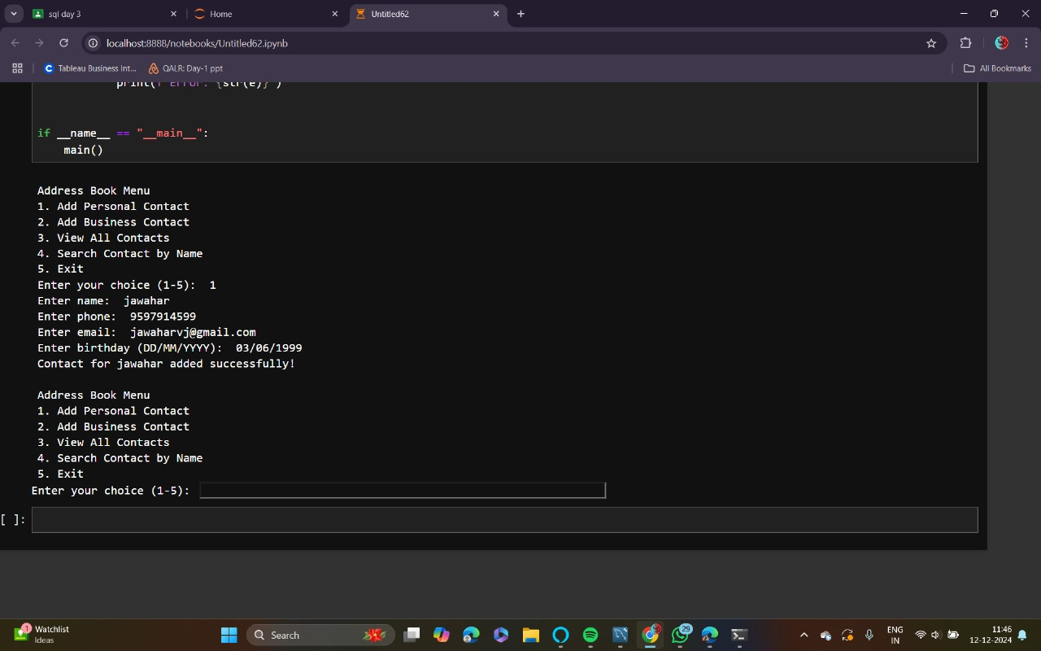

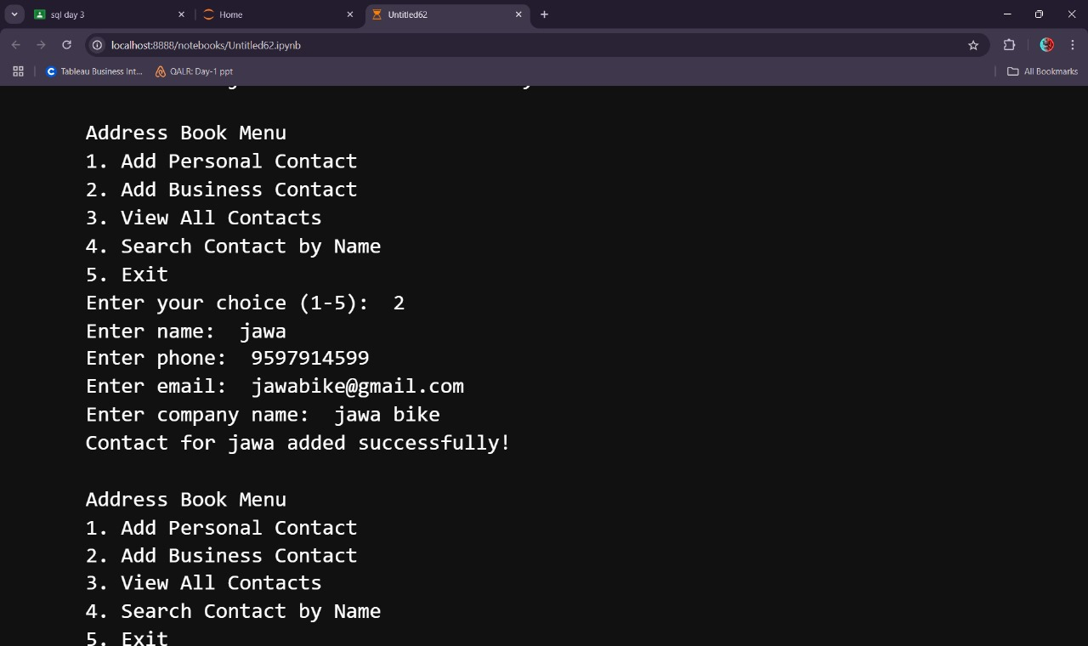

**8.Conclusion**

This address book application is a simple but effective program that demonstrates the core principles of object-oriented programming, error handling, and user interaction via a command-line interface.This code is a great foundation for building a more complex contact management system, illustrating key programming concepts while remaining simple enough for easy modification and enhancement.